Notes :
- Internal Notes Colour
- Delivery Notes Colour
- Printed notes Colour

Calendar data:

- Delivery Date <PO>
- Due Date < PO>
- Delivery scheduled <SO>

Low stock:
- We will create a setting in the “low stock” setting of general header. Where you can set the rule for low stock. For ex: the rule for low stock has a drop down to show following options : So if value is selected, whatever SFT is mentioned, if the quantity is going below it, it’ll be shown as low stock. IF under 200SFT is low stock

Recent transactions:
- A module to be created to show all the transactions. Any input of or a record of payment done or received is a transaction. And it’s receipt should be displayed in the transaction module. If there’s a credit or debit note, it’ll also be listed in a transaction.

UI Fix in dashboard. Calendar and sales is going out of bounds. View all tab is different in the sections

Slab life cycle
- Packaged : L x W <dates> <location - “B1-Main Office”>
- Received : L x W <dates> <location>
- Current : Is received, unless it is adjusted <dates> <location “A1- Main Office”>
  - Adjustment <dates> <location>
- Current : becomes - last adjustment
- Ajustment of slabs to have following options:
  - Adjust in the same slab (loss in material)
  - Adjust in multiple slabs (select number of slabs) and distribute L x W for each
  - For ex: Slab A: 10 x 10
  - Adjusting in multiple slabs, input slabs (2):
    - Slab A1 : 10 x 6
    - Slab A2 : 10 x 4

Receiving : 10x5 : 50sft @ 10 = 500
Adjustment : 10 x 2.5 : 25SFT @10 = 250

Purchase options:
- Via PO
- Via direct creation of SIPL

Create new SIPL:
SIPL number to be shown in title
Invoice # to be input valid

Containers:
- Default container number to be fetched from SIPL
  - There could be multiple containers, the list will show the default container first, with an option to add more containers.

Items
Freight Bills : <freight payables>
Other Bills : for ex: customs and brokerage charges <COA can be different>

To be merged under one name

Purchase Location and Ship to location to be as per SIPL and not to be changed

Remove CRM

Pay other bills
Should be present under payments

Supplier freight history
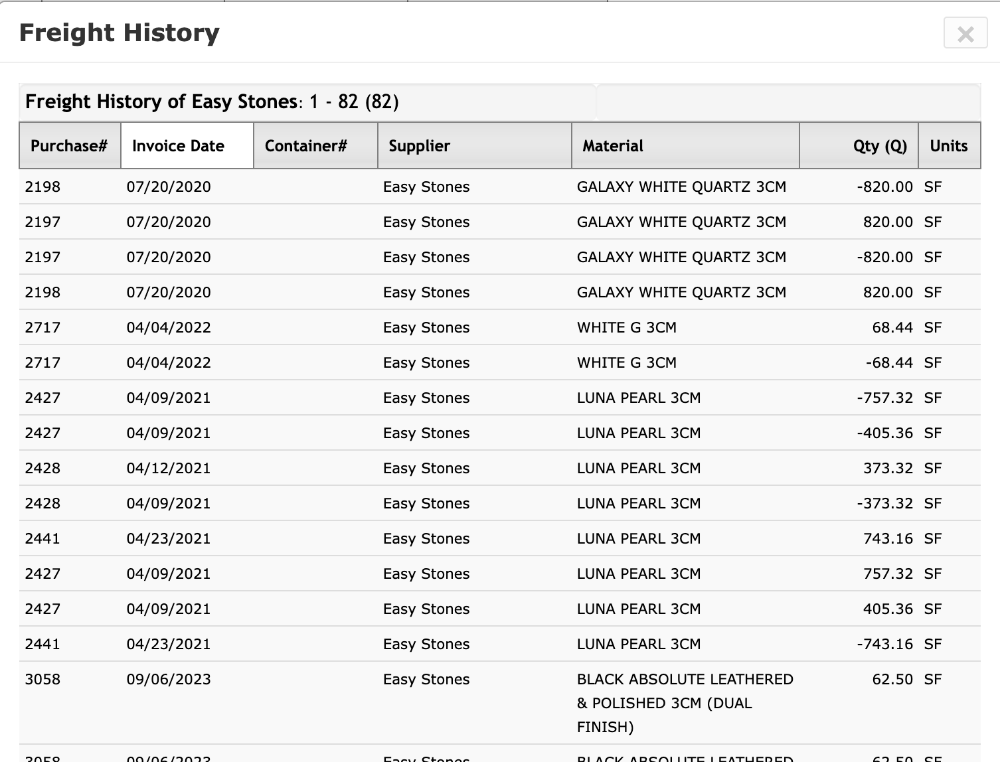

There will be 2 kinds of product listing:
- Slabs : Default (slabs), tiles, pavers = qty : L x W
- Non slabs : qty : single value

Tasks for Jatin:
Go through UI completely

